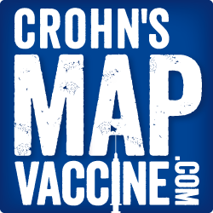

Your change will help us through phase 2 of the vaccine trial 2021.
Find us on Facebook, Twitter & Instagram
www.crohnsmapvaccine.com

