There is growing evidence that Crohn’s Disease is caused by a bacterium called Mycobacterium Avium subspecies Paratuberculosis (MAP for short). Please show your support by donating what you can to the vaccine research at Kings College London. Thank you.

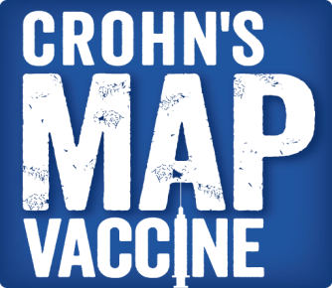 

|  |  |
| --- | --- |
| Name | Amount |
|  |  |
|  |  |
|  |  |
|  |  |
|  |  |
|  |  |
|  |  |
|  |  |
|  |  |
|  |  |
|  |  |
|  |  |
|  |  |
|  |  |
|  |  |
|  |  |
|  |  |
|  |  |
|  |  |
|  |  |
|  |  |
|  |  |
|  |  |
|  |  |
|  |  |
|  |  |
|  |  |
|  |  |
|  |  |
|  |  |
|  |  |
|  |  |
|  |  |
|  |  |
|  |  |
|  |  |
|  |  |
|  |  |
|  |  |
|  |  |
|  |  |
|  |  |
|  |  |
|  |  |