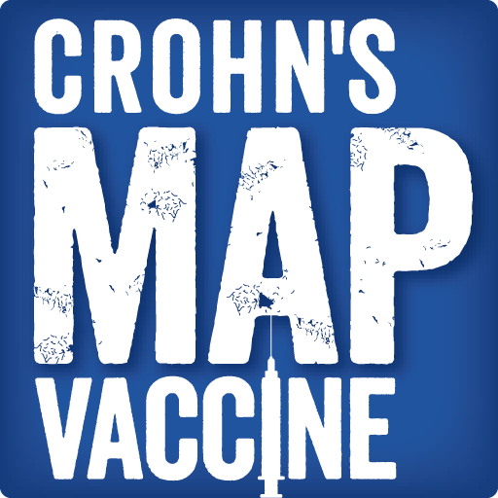 | How to create an individual JustGiving fundraiser to raise funds directly for Crohn’s MAP vaccine human trials at King’s College London

- Go to http://www.justgiving.com/ page
- Press Get Started and sign in
- Type “King” onto the search field and press search
- Choose King’s College London
- Choose What you’re doing (e.g. Personal challenge)
- Finalise your selection and create your page (example below):
Please add Crohn’s MAP vaccine code –MEN9150 on to the end of web address you choose. This will guarantee that the funds donated via your page support directly the development of Crohn’s MAP vaccine.

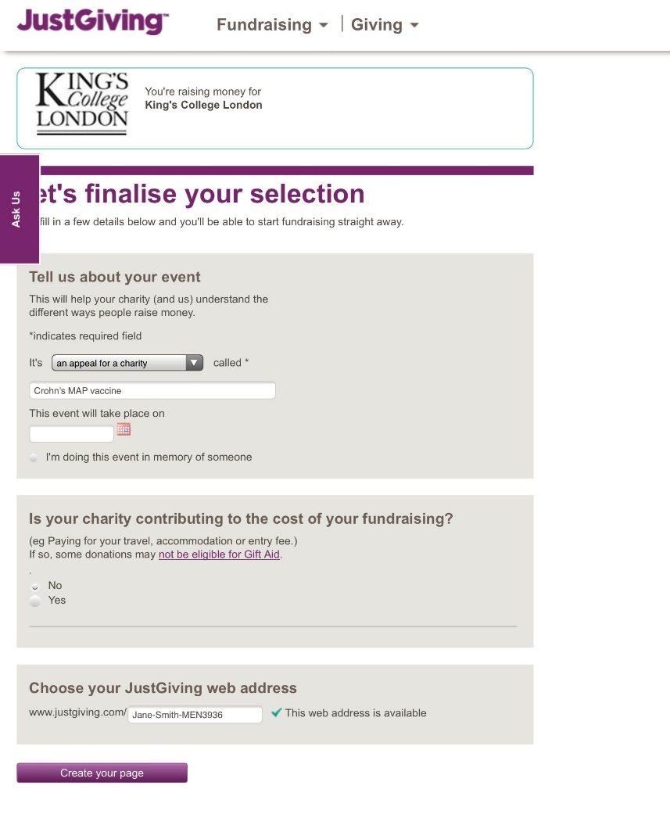
- Personalise your page: We would like you to use the following text though for the following parts:
- Tell us what you are doing and why:
Raising money for the Crohn’s MAP Vaccine Fund for
- Because:
it’s time to cure Crohn’s disease
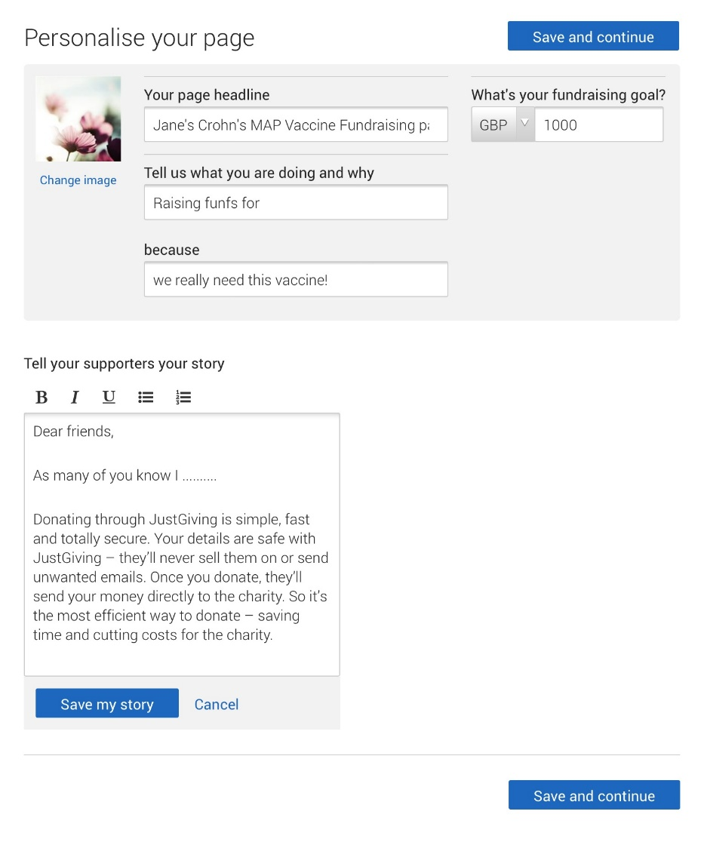

- Your page should look like this at this point:

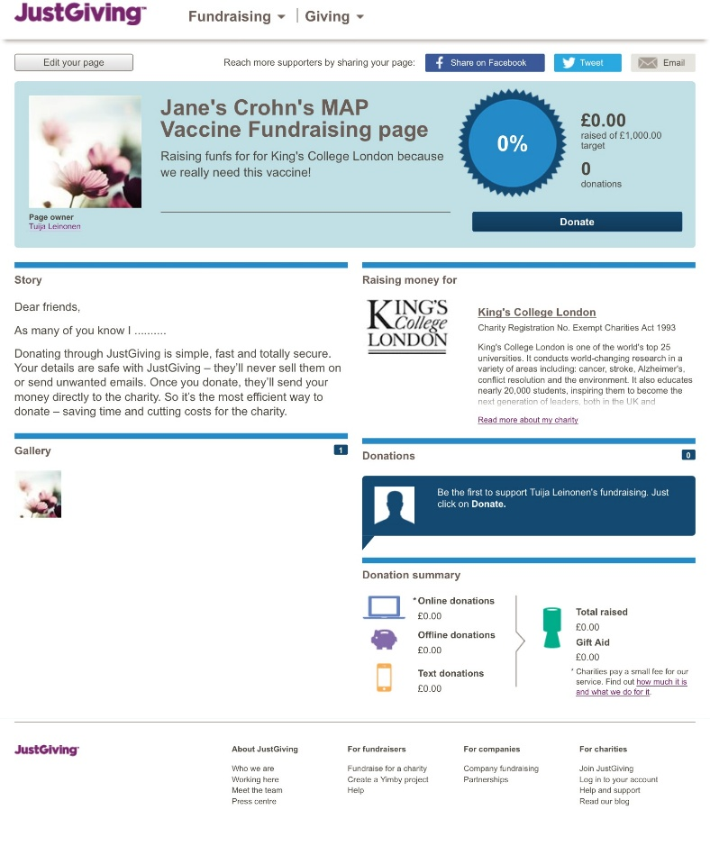
- You can easily edit the page, add photos, etc.
Please remember to update also your Thank-you message!
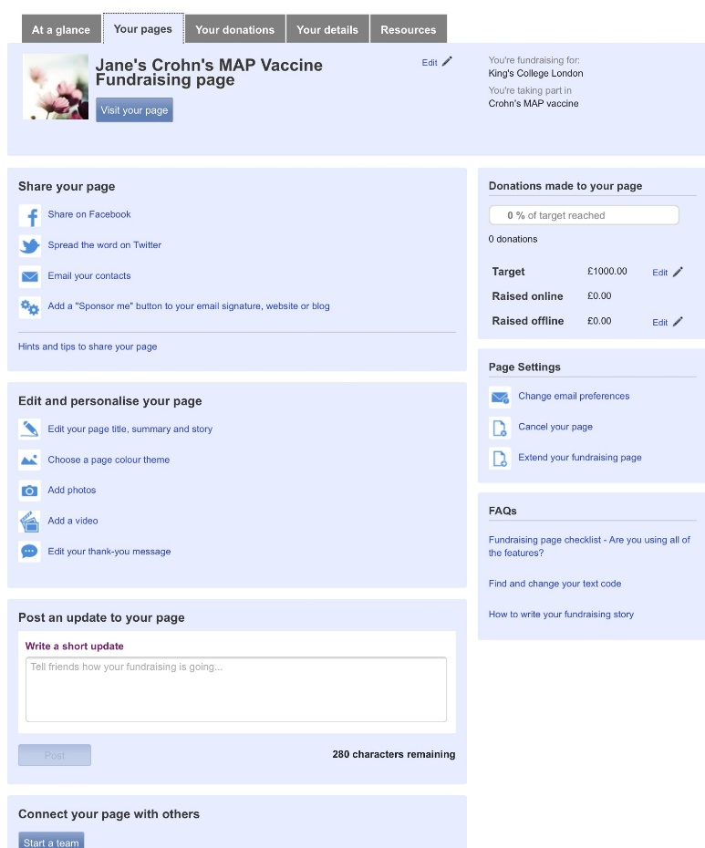

- Here is the team logo. You are free to use it if you wish, but it is of course optional!
(you can copy it from here)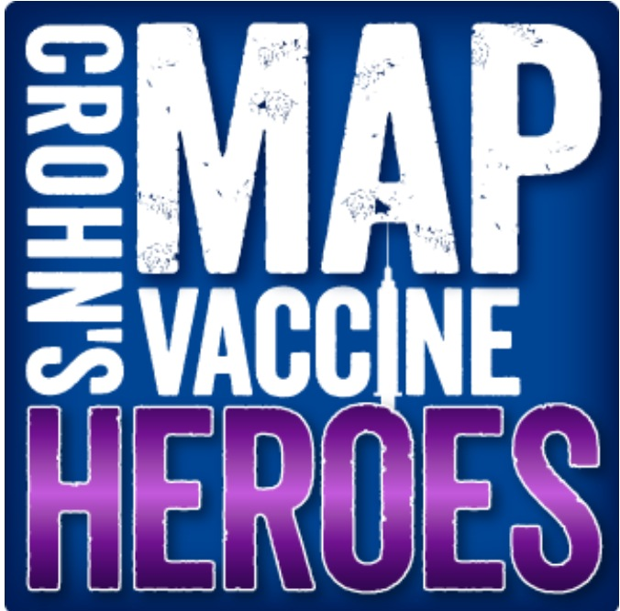

- Please note that you can also add the possibility for text donations (in the UK), see JustGiving FAQ ‘Find and change your text code’.

- Important: After you have created your page, please check that the web address of your page ends with the code –MEN9150.

If it doesn’t you need to send an email to: help@justgiving.com with the following content:
I want to raise funds for the Crohn's MAP vaccine campaign of King's College London and I have already created the following fundraising page:
http://www.justgiving.com/Jane-Smith

Could you please add the code –MEN9150 (Crohn’s MAP vaccine code) to the end of the URL.
This will guarantee that the funds donated via your page support directly the development of Crohn’s MAP vaccine.

After your page is ready, please go to the CMV Heroes JustGiving team page and click “Join the team”. The administrator will add your page to the team page.

https://www.justgiving.com/teams/crohnsmapvaccineheroes

